###### https://d271l2xf0l385q.cloudfront.net/dKU1R2aHSmpIqgtYR1-2https://d271l2xf0l385q.cloudfront.net/2znOu2200RKxNaKtR1-2https://d271l2xf0l385q.cloudfront.net/QJtYti8N5OpCz43sR1-2https://d271l2xf0l385q.cloudfront.net/j3qiYJguVDkLpKOrR1-2https://d271l2xf0l385q.cloudfront.net/SnXzaDTOcEf3kTMQR1-2https://d271l2xf0l385q.cloudfront.net/0LoTrtJVf8fdDLj2R1-2https://d271l2xf0l385q.cloudfront.net/gCe2GIJ2V73K3at9R1-2https://d271l2xf0l385q.cloudfront.net/ElwYtoiTCtJLo2PMR1-2https://d271l2xf0l385q.cloudfront.net/VD8WiboFtmU3oD7wR1-2https://d271l2xf0l385q.cloudfront.net/JSkJN4JWeEHkue7WR1-2https://d271l2xf0l385q.cloudfront.net/Yls64IU0qumCDFDSR1-2https://d271l2xf0l385q.cloudfront.net/uD1cey85tRebe2qBR1-2https://d271l2xf0l385q.cloudfront.net/2BBzc4TT8Xdo7J6LR1-2https://d271l2xf0l385q.cloudfront.net/y65aPFPZ1zGj3JKbR1-2

Clwb Ilar Handbook

###### Clwb Ilar

After School Club Handbook

The Aim

We aim to provide a high quality After School Club that meets the needs of both parents and children. For parents, this means knowing that your child is safe and happy in a club that is reliable and offers a consistent service. For a child this means an environment that is safe, supportive and encouraging.At the After School Club we believe all children have the right to play.Play is the basis to providing healthy development and the well being of individuals. The club will provide a balanced structure of activities and play experiences. The Club intends to offer a child centred environment meeting the social physical, intellectual, creative and emotional needs of each individual child.

Numbers of Children catered for

Clwb Ilar provides this service for children of Llanilar Primary School children aged between 4-11 years. The Club caters for a maximum of 24 children per session.

Languages used

The main language of the Club is Welsh but we will use English as a way of communicating with children and parents/carers who have a little understanding or learning the Welsh Language. Bilingual signs and letters are used to ensure important notices and information are received and understood.

Opening hours

Clwb Ilar runs from Monday to Thursday during school term time **ONLY**.

The Club is available between 3.30 pm and 5.30 pm.

Children are collected by a member of staff from their classroom, then they are escorted to the school hall where the register is taken. Children will be required to wear illuminous jackets whilst they are escorted to the Old School which is only a short walking distance from the school.

Contact information

Our contact address is: Yr Hen Ysgol, Llanilar, Aberystwyth

Tel: 07531330565 / 01974241344 (Primary School Phone number)

We need to be aware of your contact details and have information regarding your child/ren. **PLEASE COMPLETE THE REGISTRATION FORM AND KEEP US INFORMED OF ANY CHANGE OF DETAILS.**

Miss Nia Evans will be available to take bookings/collect money and answer any queries you may have in regards to the afterschool club.

Staff

|  |  |  |  |
| --- | --- | --- | --- |
| **Miss Nia Evans** | **Miss Lowri Tudor** | **Miss Rhiannon Hopkins** | **Ms Nia Jones**  (Bank Staff) |
|  |  |  |  |
| Senior  Play leader | Play Leader | Assistant Playworker | Assistant Playworker |

There are two qualified members of staff giving a ratio of 1 staff member to 8 children working each session: An additional member of staff will be required to work once numbers exceed 16 children. Staff members hold a variety of qualifications ranging from Degrees in Early Years Education and NVQ 4. An individual staff member is currently working towards their Play Work level 3 Qualification with two also working towards their Level 3 Sports Leaders through the Urdd.

**ALL** members of staff hold an up to date DBS Certificate.

**ALL** members of staff hold an up to date certificates in First Aid, Food Hygiene and Child protection.

# Volunteers will assist at various times during the year and they are required to obtain a DBS before they are allowed to assist with the children within the after school club.

# Food

Snacks are be provided at the beginning of each session, this will be in line with our healthy eating policy, and to suit your child’s dietary needs and preferences.

|  |  |  |  |  |
| --- | --- | --- | --- | --- |
| Wythnos/Week | **Dydd Llun /**  **Monday** | **Dydd Mawrth /**  **Tuesday** | **Dydd Mercher /**  **Wednesday** | **Dydd Iau /**  **Thursday** |
| **_ _/_ _/_ _** | Tost/  *Toast* | Bagles | Cracers a Chaws/  *Crackers & Cheese* | Brechdan ham, jam neu caws /  *Ham, Jam or Cheese Sandwich* |
| **_ _/_ _/_ _** | Cracers a Chaws/  *Crackers & Cheese* | Grawnfwyd /  *Cereal* | Tost /  *Toast* | Bagles |
| **_ _/_ _/_ _** | Pitsa /  Pizza | Cracers a Chaws/  *Crackers & Cheese* | Brechdan ham, jam neu caws /  *Ham, Jam or Cheese Sandwich* | Wraps Ham neu Caws/  *Cheese or Ham Wrap* |
| **_ _/_ _/_ _** | Grawnfwyd / *Cereal* | Tost /  *Toast* | Crempog /  *Pancakes* | Brechdan ham, jam neu caws /  *Ham, Jam or Cheese Sandwich* |
| **_ _/_ _/_ _** | Bins ar Dost /  *Beans on Toast* | Brechdan ham, jam neu caws /  *Ham, Jam or Cheese Sandwich* | Wraps Ham neu Caws/  *Cheese or Ham Wrap* | Cracers a Chaws/  *Crackers & Cheese* |

Here is an example of our menu plan ………

There is also a choice fruit/salad and water is always available.

# Any dietary needs / requirements or allergies need to be brought to our attention through talking to Miss Nia Evans (Senior Club Leader) and by filling in the appropriate information on the registration form.

# Facilities

The old School Centre has a small kitchen were all meals/ snacks are stored and prepared. Only staff members are allowed in this area and children are prohibited to enter to ensure their safety due to the equipment and utensils it contains.

Activities will be planned every half term and a timetable will be produced outlining the activities for each night but we offer opportunities for free play and children’s choice daily.

Children will be encouraged to participate in the planning of activities during circle time/group discussions and ideas for equipment. There is also a suggestion box for those who may like to forward their ideas e.g. parents/carers and children.

Here’s an example of an activity plan …

|  |  |  |  |  |
| --- | --- | --- | --- | --- |
| Wythnos/Week | **Dydd Llun /**  **Monday** | **Dydd Mawrth /**  **Tuesday** | **Dydd Mercher /**  **Wednesday** | **Dydd Iau /**  **Thursday** |
| **_ _/_ _/_ _** | Pwl, Gwisgo Fyny a ipads /  *Pool, Dressing up & ipads* | Bingo | Uni Hockey | Noson Technoleg  *Technology Night* |
| **_ _/_ _/_ _** | Celf a Chrefft /  *Arts and Crafts* | Coginio /  *Cooking* | Gemau Bwrdd /  *Board Games* | Siop, Gwisgo Fyny a Pwl /  *Shop, Dressing Up & Pool* |
| **_ _/_ _/_ _** | Noson Technoleg /  *Technology Night* | Coginio /  *Cooking* | Celf a Chrefft /  Arts and Crafts | Dewis y Plant / *Children’s Choice* |
| **_ _/_ _/_ _** | Celf a Chrefft /  *Arts and Crafts* | Lego / K’nex | Coginio /  *Cooking* | Bingo |
| **_ _/_ _/_ _** | Gemau Bwrdd a Jigso /  *Board Games & Jigsaws* | Noson Technoleg /  *Technology Night* | Uni Hockey | Celf a Chrefft /  *Arts and Crafts* |
| **_ _/_ _/_ _** | Dewis y Plant /  *Children’s Choice* | Coginio /  *Cooking* | Celf a Chrefft /  *Arts and Crafts* | Coginio  *Cooking* |

An activity plan is displayed on the Clwb Ilar display located within the school hall, also on the Clwb Ilar display located in the entrance hall of the Old School Centre and on the “Clwb Ilar” drop down box on the school website.

The timetable produced provide seasonal planned activities for the children to partake in but with the option of free play and freedom of choice in what activities they want to take part in within the time they are with us at the After School Club.

At times the children will have the opportunity to take part in off-site activities – the park, the school filed (during dry summer months), the river, cycle path or the millennium lake. For your child to take part in these activities you will need to fill in a consent form prior to the activity.

When children take part in off-site activities e.g. park please refer to the note displayed on the entrance door which will display the location of your child/ren.

Pictures of your child/children will be taken as part of the process of gathering evidence to show what activities the children have the opportunities to take part in at the club. These are displayed on the “Clwb Ilar” display for parents and carers to see when collecting. Written permission will need to be obtained before pictures can be taken and displayed

**Also new for 2020 these picture posters will be available to seen on the school website via the “Clwb Ilar” drop down tab.**

FEES

When booking a place for your child/children in the After School Club, it will be necessary to pay for that place when booking. We will not be able to accept the child if the place hasn’t been paid for. The cost will be £6.50 per child and £6.00 for siblings for each session. 48 hours’ notice is required if your child/children will not be attending on the specified day. DUE TO HIGH DEMAND, BOOKING AHEAD IS ESSENTIAL.

DAILY SET ROUTINE

3.40 p.m. Every child wash their hands, have a snack, and discuss what additional toys/games (in addition to the planned activity) they would like to play with.

4.15 p.m. The children have 15 minutes outdoor free time/play (weather permitting).

4.30 p.m. Everyone returns to the building and start the activities.

5.15 p.m. All children are encouraged to help tidy up and then have circle time etc. (whilst waiting to be collected by parents).

HEALTH AND SAFETY

### Clwb Ilar has a Health and Safety Policy that complies with the statutory legal requirements.  However, over and above this, every care is taken to try and ensure that all our children are properly supervised in healthy, safe conditions throughout the session.

Children may not leave the club without their parent or guardian and doors are kept closed and locked and only opened when known parent or guardian present themselves accordingly. Parents are asked to inform us whenever someone new or unknown to staff is due to collect children from the old school.

##### MEDICATION

### If a child does need to take medicine during a session at the After School Club, parents need to complete the medicine form noting down the name of the child, dosage and times along with a signature. Club leader will take responsibility of the medicine during school hours, within the safety of the staff room and will transport it to the old school centre where it will be placed in a locked cupboard to ensure children’s safety.

# CODES OF CONDUCT/ BEHAVIOUR POLICY

Llanilar After School Club aims to promote positive behaviour by treating everyone connected with the club with dignity, respect equality and fairness at all times; by creating a safe and secure environment free from bullying, harassment and discrimination.

We will achieve this by:

* Valuing each child as an individual.
* Ensuring that staff interaction with children builds confidence, encourages learning new skills and values the contributions of children and young people.
* Working with parents to promote positive behaviour and deal with difficult behaviour.
* Encouraging the participation of children in the life and work of the club.
* Ensuring that staff are trained in recognising harm, abuse, neglect, bullying and discrimination and that they actively challenge and respond to such behaviour.
* Encourage children to take responsibility for their own behaviour.
* Having a child protection policy.
* Having a code of behaviour that it consistently applied.
* Having a safe environment that meets all relevant legislation and by carrying out regular risk assessments.

# CONFIDENTIALITY

The operation of Llanilar After School Club involves the sharing of information between users and the club. In order to respect the dignity and privacy of all users, the club will actively promote confidentiality in the following ways.

* Providing guidelines for staff on required records/reports.
* Providing guidelines for staff in the handling of confidential/ sensitive information.
* Providing secure storage for files and information.
* Adhering to all relevant legislation in the keeping of records.
* Providing parental/carer access to their child’s own records.
* Undertaking not to disclose confidential information unless required to do so.

### SECURITY

Please note that the entrance door is kept locked at all times to ensure the safety of your child/children. Please knock on the door and make yourselves known to the staff.

You are also asked to sign the collection book with, they child’s name, parents/carers signature along with time collected when collecting your child/children

#### FIRST AID/FIRE DRILL

We have a complete first aid box on the premises and it is checked at the beginning of every term and every month afterwards.

We practice a fire drill every half term to familiarise the children with the procedure.

Website

New to 2020, Clwb Ilar has information on the Primary School Website: see “Clwb Ilar” tab.

<http://llanilar.ceredigion.sch.uk>

Information provided:

* An electronic copy of the Clwb Ilar Handbook.
* Copy of registration form.
* Information regarding staff.
* Half term activity plans.
* Pictures of activities that the children have taken part in.
* Recent CSSIW Inspection Report.

FURTHER INFORMATION AND CLARIFICATION

We hope that this handbook gives you some idea of what your child will experience here at Clwb Ilar After School Club.

Although every effort has been made to ensure that the information in this Handbookis correct, there may be changes that are beyond our control. Any changes that do occur during the year will be notified to the parents through letters. If however you do have any queries or would like any further information please do not hesitate to contact Miss Nia Evans.

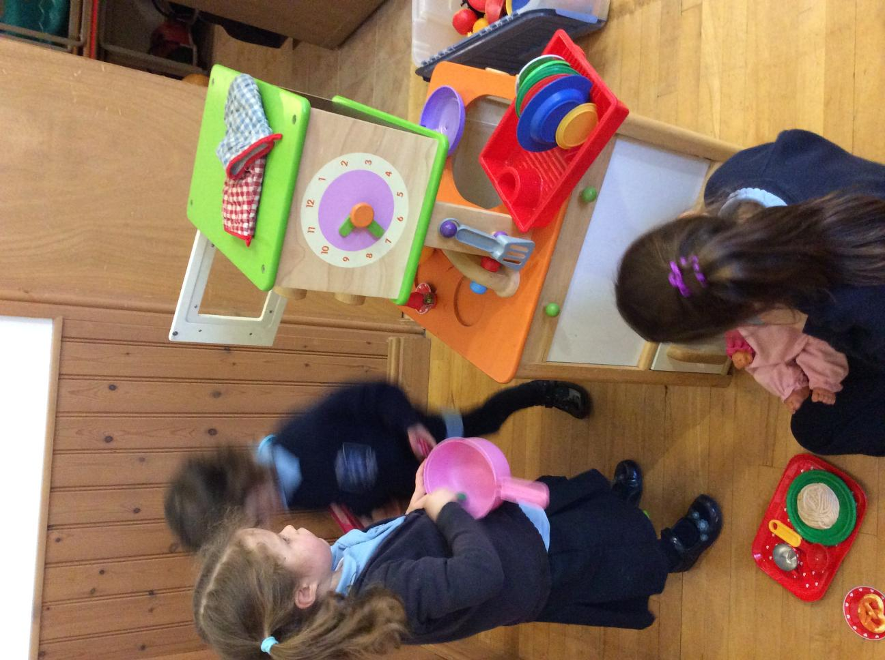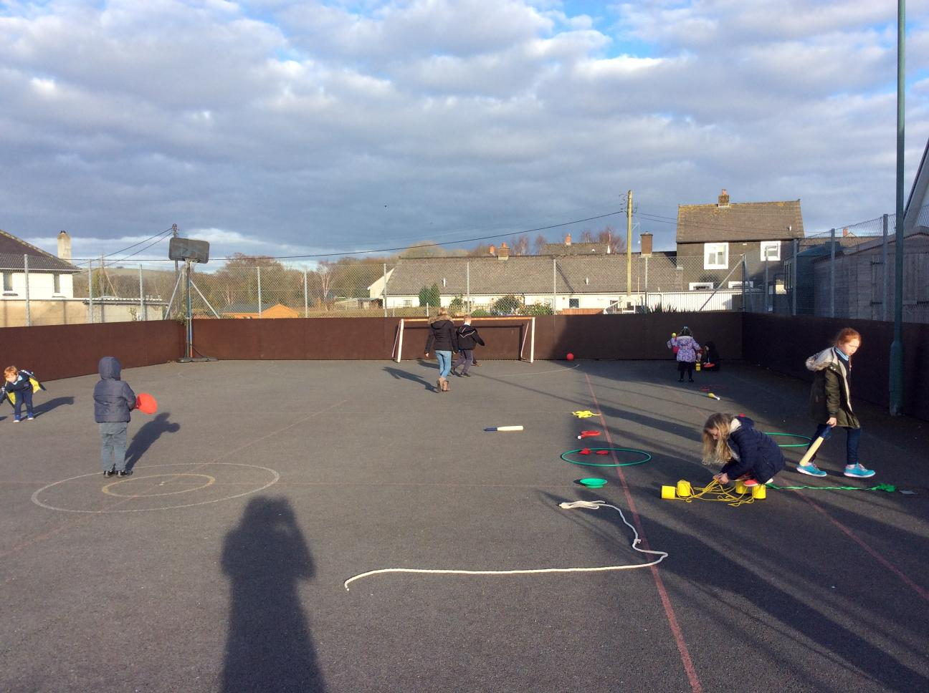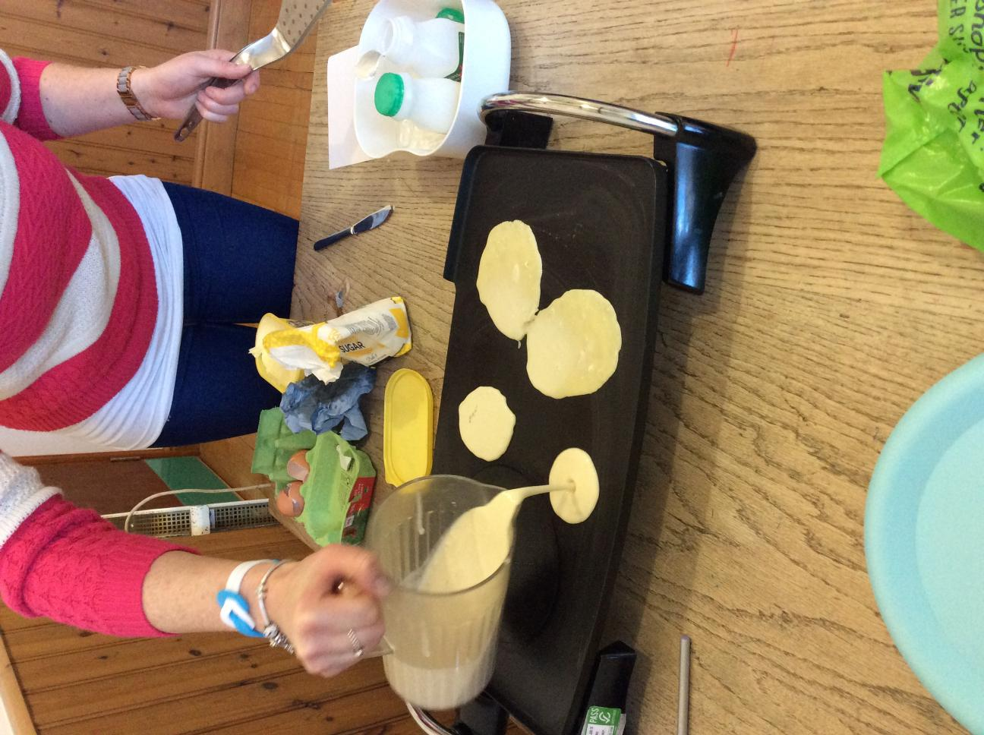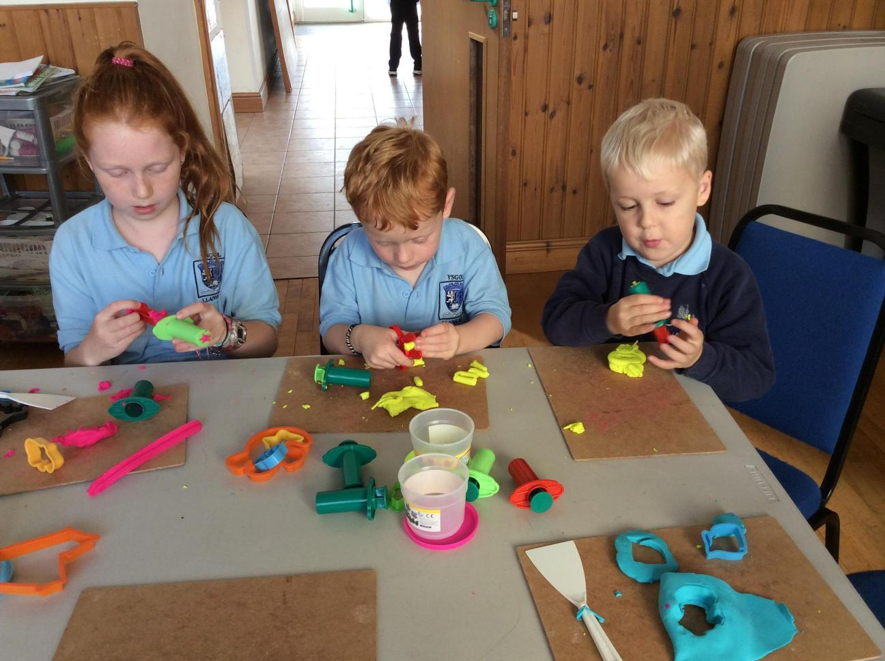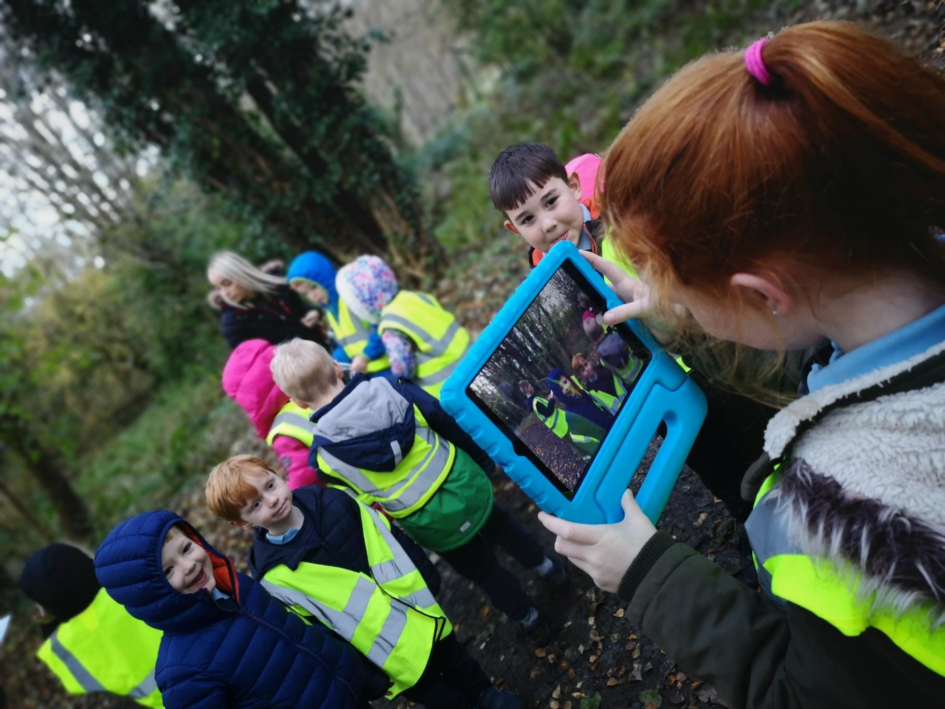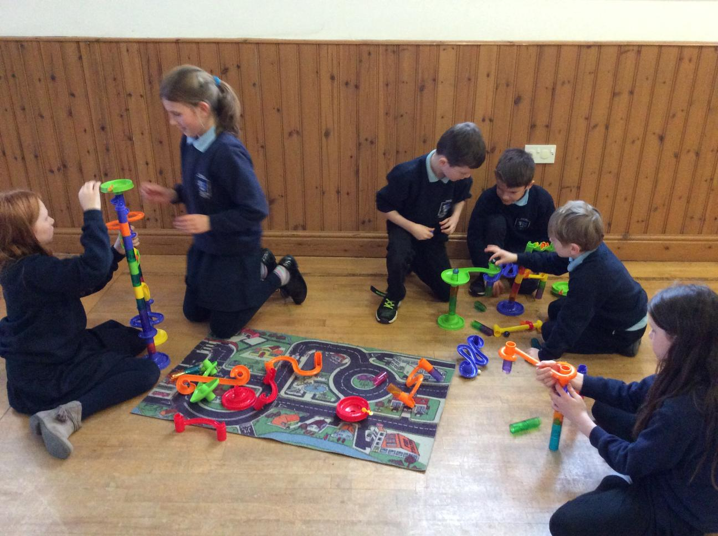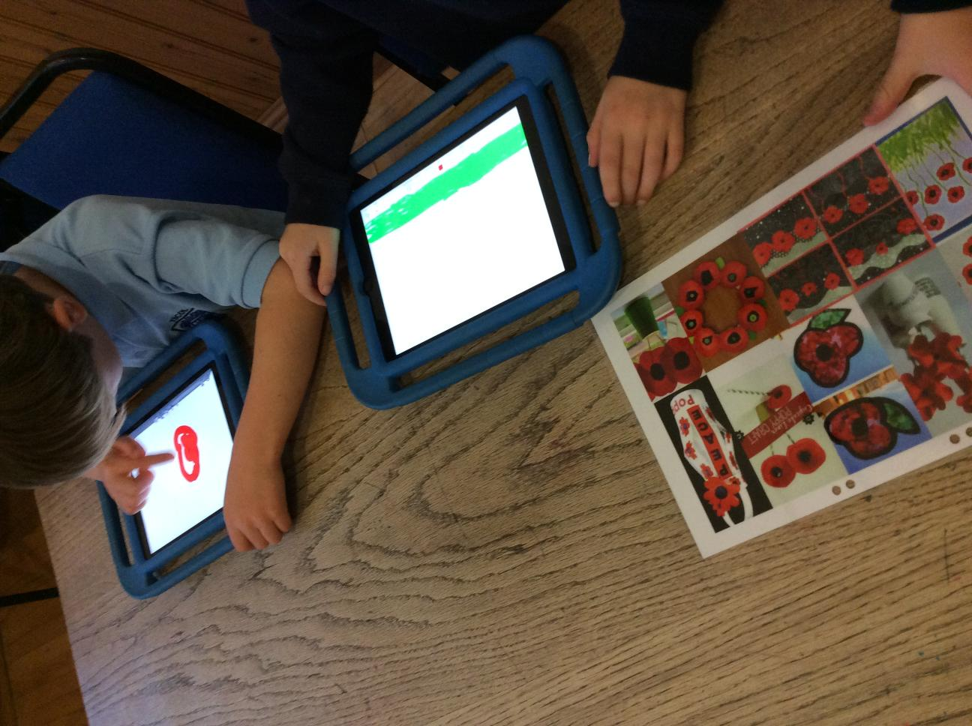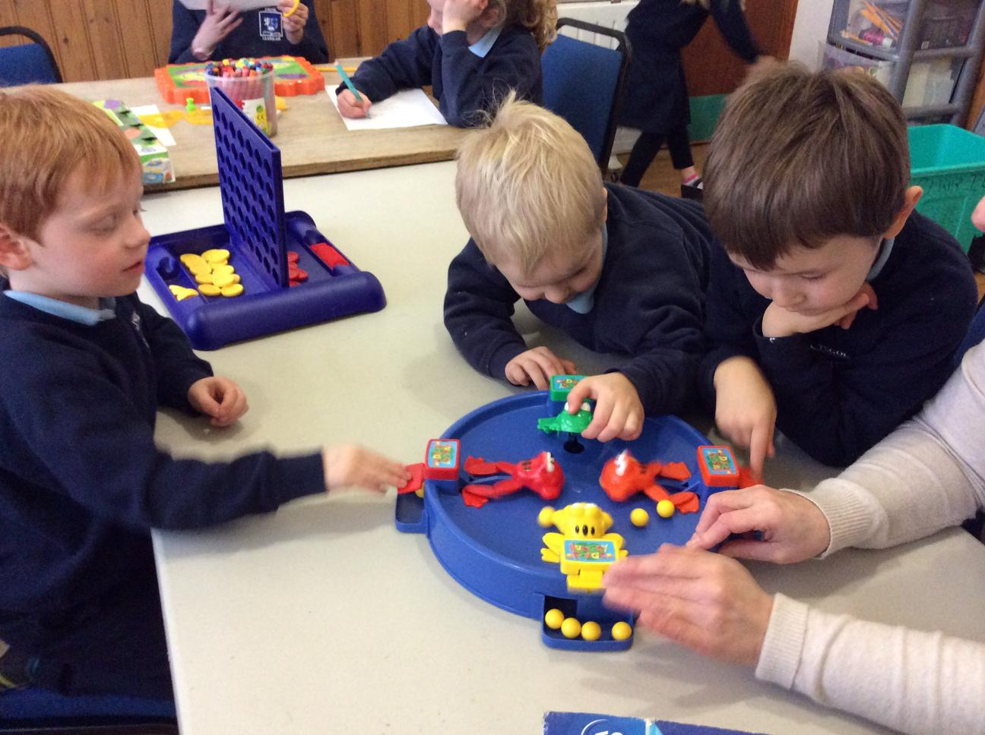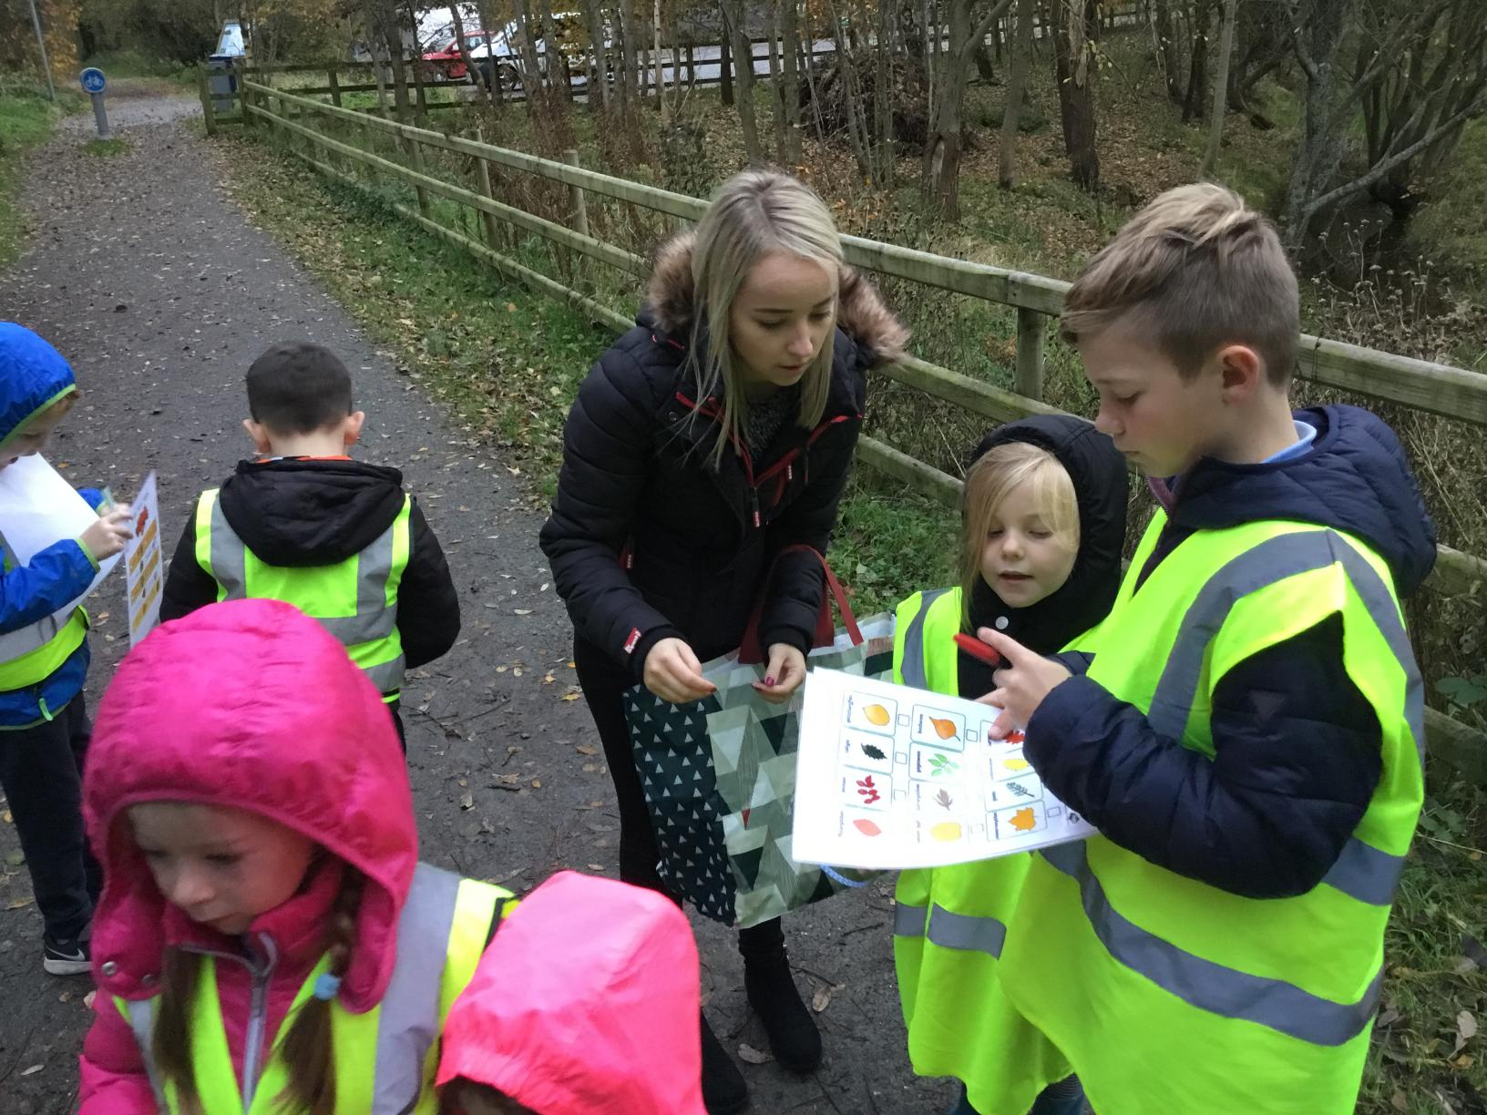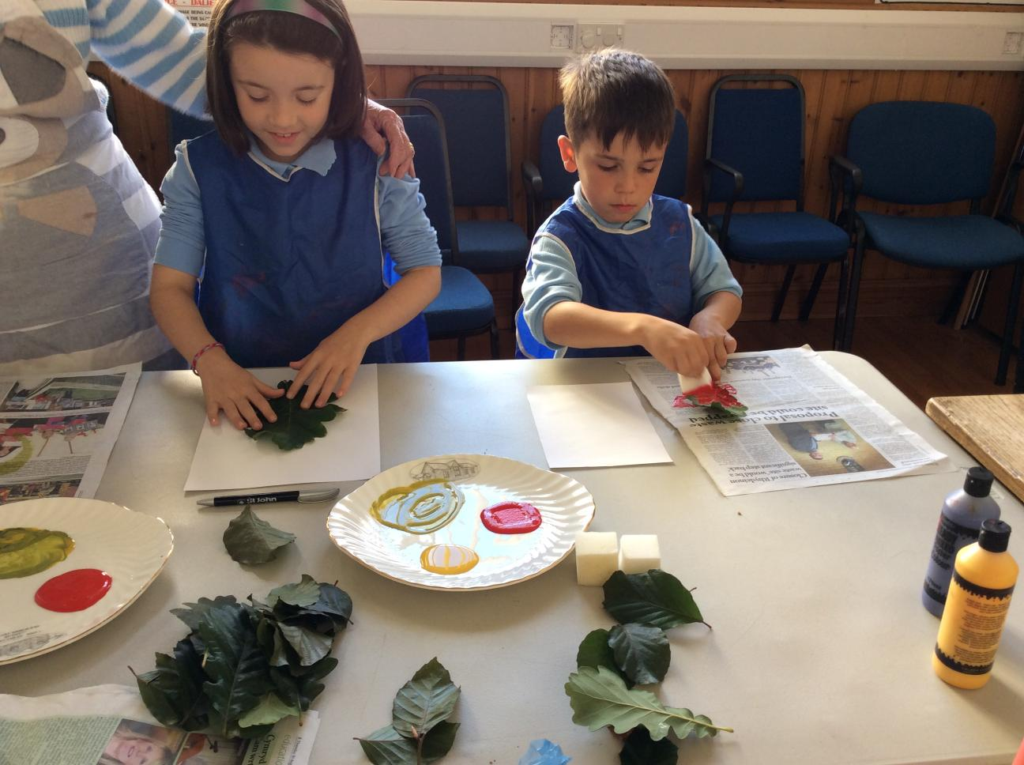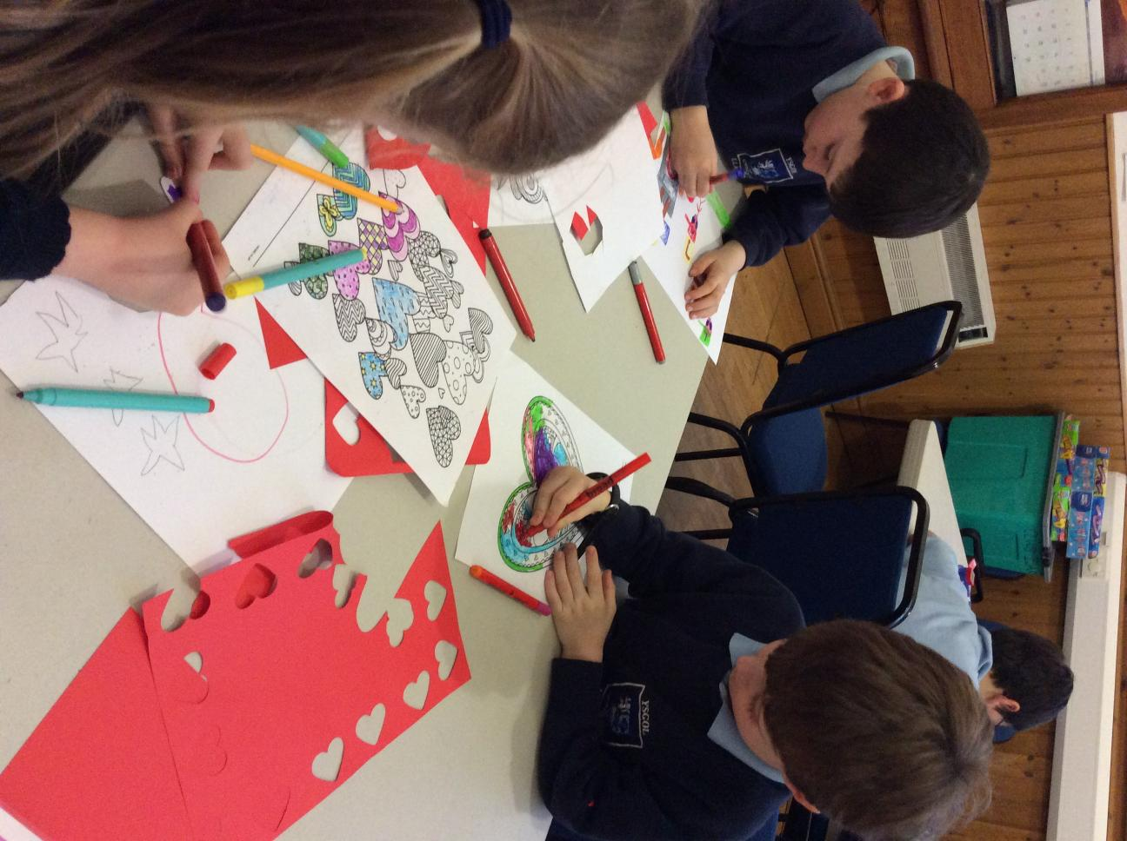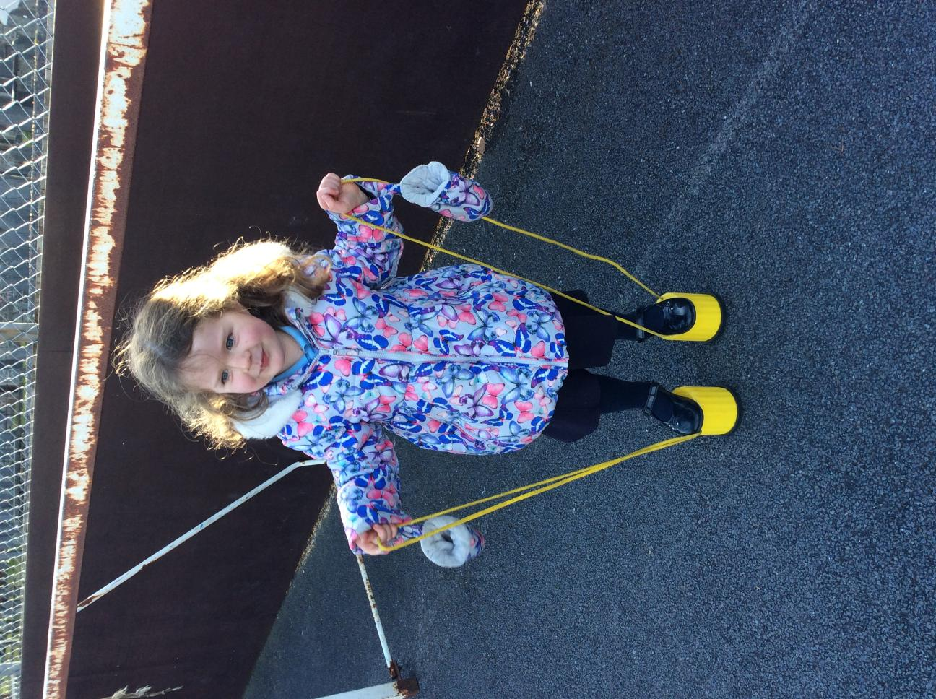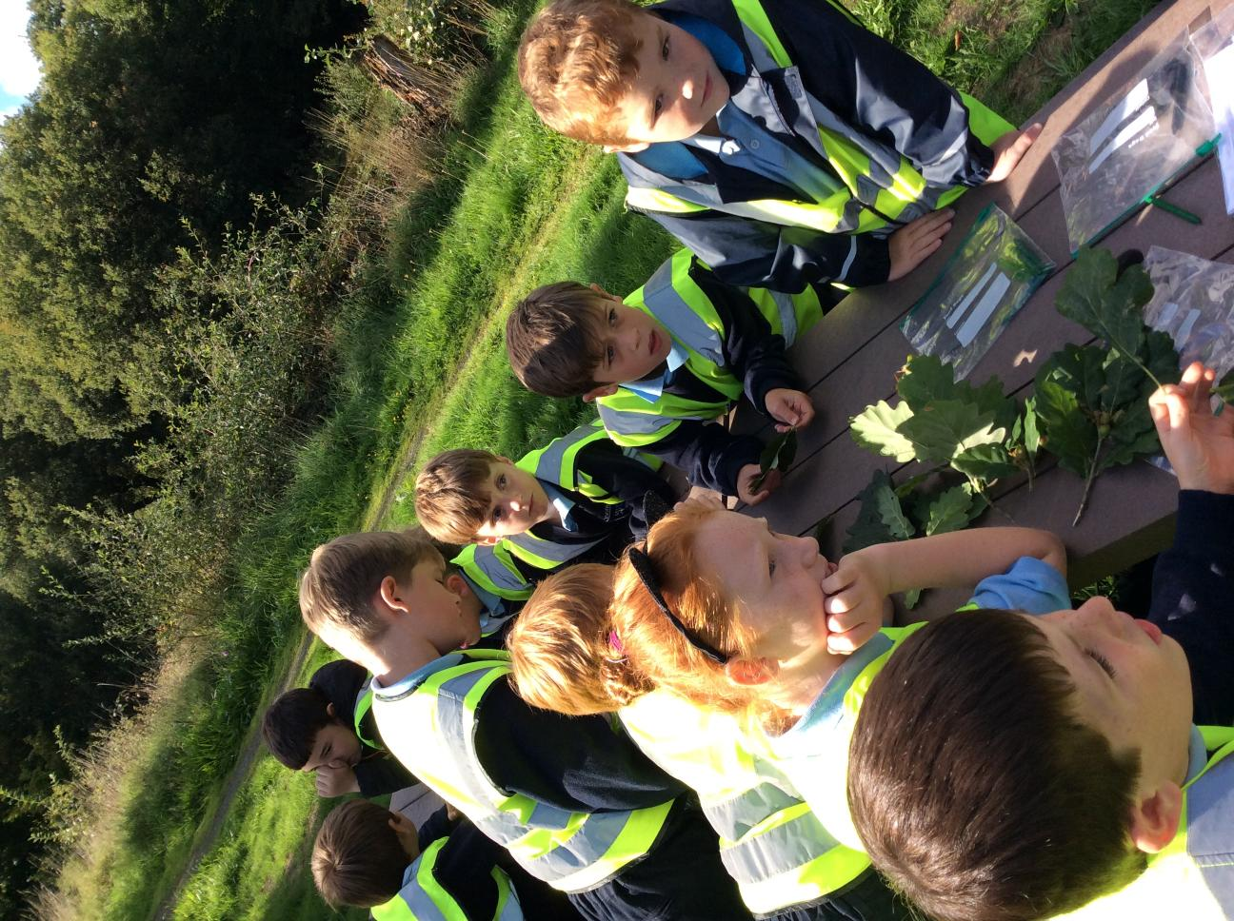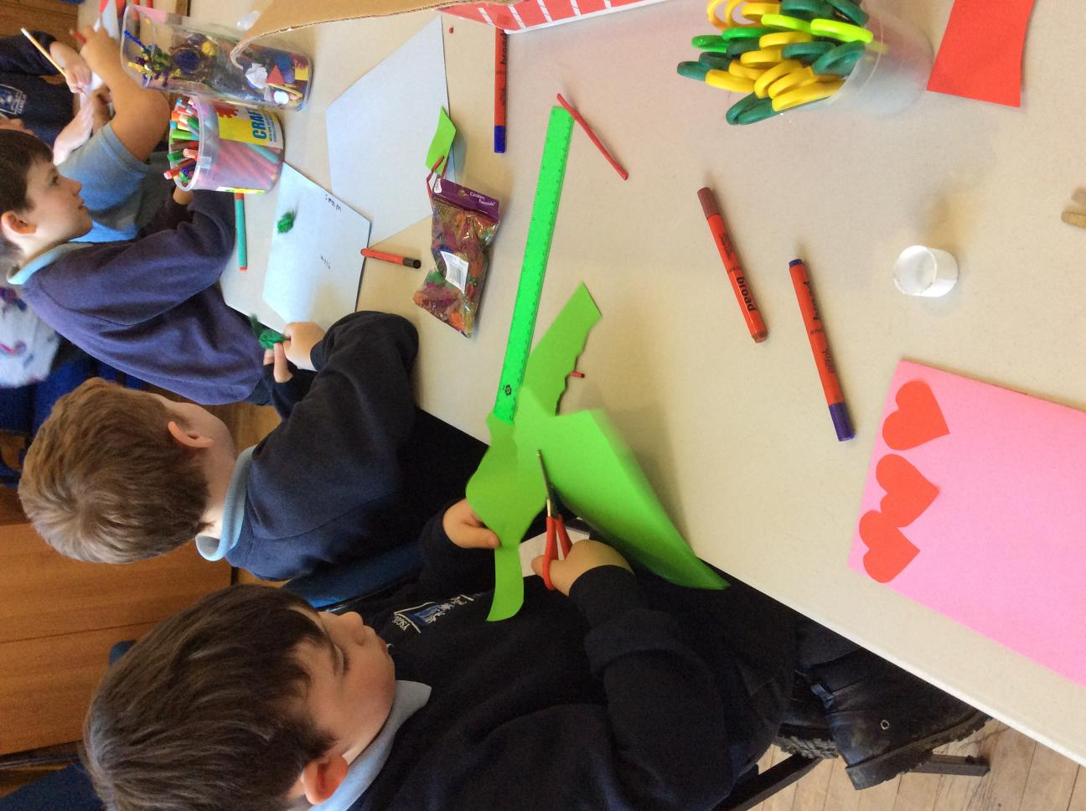

Llawlyfr Clwb Ilar

Clwb Ilar

###### Llawlyfr y Clwb ar ol Ysgol

Y NOD

ein bwriad yw i ddarparu Clwb ar ôl Ysgol o ansawdd uchel sydd yn cyrraedd gofynion rhieni a phlant yr ysgol. I’r rhieni, mae hyn yn golygu fod ei plant yn ddiogel ac yn hapus mewn clwb sydd yn dibynadwy ac yn cynnig gwasanaeth cyson. I’r plant mae hyn yn meddwl cynnig amgylchedd sydd yn ddiogel a chefnogol. Yn Clwb Ilar rydym yn credu fod gan pob plentyn yr hawl i chwarae. Mae chwarae yn sail ar gyfer darparu datblygiad bositif ac ar gyfer datblygu lles plant. Bydd y clwb yn darparu strwythur cytbwys o weithgareddau sydd yn cyrraedd gofynion cymdeithasol, corfforol, deallusol, creadigol a emosiynol bob plentyn.

NIFER Y PLANT SY’N DERBYN Y DDARPARIAETH

Mae’r Clwb yma yn cynnig gwasanaeth ar gyfer disgyblion Ysgol Gynradd Llanilar yn unig - rhwng 4 -11 oed. Mae’r Clwb yn gallu ddarparu ar gyfer 24 un unig o blant mewn un sesiwn.

YR IEITHOEDD A DDEFNYDDIR

Prif iaith y clwb yn Cymraeg ond mi fyddwn yn cyfathrebu ar lafar ac yn ysgrifenedig gyda rhieni neu gofalwyr sydd yn ansicr or iaith neu yn dysgu’r iaith Gymraeg yn Saesneg neu yn ddwyieithog. Mi fydd yn hyn yn mwyn sicrhau ei bod yn deall negeseuon/cynnwys llythyron .

Mi fydd hyn yn sicrhau dealltwriaeth pob rhiant/gofalwr.

ORIAU AGOR

Mae Clwb Ilar yn rhedeg o ddydd Llun i ddydd Iau yn ystod tymor yr ysgol **YN UNIG**.

Bydd y Clwb ar agor rhwng 3.30 y.p a 5.30 y.p.

Caiff y plant eu casglu gan aelod o staff o’i dosbarthiadau ysgol ac yna ei harwain i neuadd yr ysgol. Yma mae gofrestr yn cael ei gwneud i cadarnhau presenoldeb y plant sydd wedi archebu ei lle. Mae angen i pob plentyn gwisgo siaced fflwroleuol er mwyn cerdded i fyny i’r Hen Ysgol sydd ond ychydig bellter o’r ysgol.

GWYBODAETH GYSWLLT

Cyfeiriad Clwb Ilar yw: Yr Hen Ysgol, Llanilar, Aberystwyth.

Ffôn: 07531330565 neu ffoniwch yr ysgol ar : 01974241344

Mae gofyn i ni gael eich manylion cyswllt a gwybodaeth ynglŷn â’ch plentyn/plant.

**GOFYNNIR I CHI LENWI’R FFURFLEN GOFRESTRU A RHOI GWYBOD I NI AM UNRHYW NEWID YN YR WYBODAETH.**

Bydd Miss Nia Evans ar gael i cofnodi sesiynau hoffech archebu lle, i gasglu arian ac i ateb unrhyw ymholiadau a fydd gennych.

Staff

|  |  |  |  |
| --- | --- | --- | --- |
| **Miss Nia Evans** | **Miss Lowri Tudor** | **Miss Rhiannon Hopkins** | **Ms Nia Jones**  (Staff Banc) |
|  |  |  |  |
| Uwch Arweinydd Chwarae | Arweinydd Chwarae | Gweithiwr Chwarae Cynorthwyol | Gweithiwr Chwarae Cynorthwyol |

Mae yna dwy aelod o staff cymhwysol yn gweithio pob sesiwn sydd yn rhoi cymhareb 1 aelod o staff i bob 8 plentyn. Mi fydd aelod ychwanegol o staff yn ofynnol unwaith mae rhifau plant yn fwy na 16. Mae gan aelodau staff amrywiaeth o cymwysterau: Gradd mewn Addysgu Blynyddoedd Cynnar ac NVQ 4. Mae un aelod o staff yn gweithio tuag at cymhwyster Gwaith Chwarae lefel 3 ac mae dwy yn gweithio tuag at cymhwyster Arwain Chwaraeon lefel 3 trwy’r Urdd.

Mae gan **BAWB** tystysgrif DBS. Mae gan **BAWB** cymhwyster Cymorth Cyntaf, Amddiffyn Plant a Hylendid Bwyd.

Ar adegau mi fydd gwirfoddolwyr yn cynorthwyo o bryd i’w gilydd yn ystod y flwyddyn ac ma angen iddynt hwy hefyd cael tystysgrif DBS cyn ei bod nhw’n gallu cynorthwyo gyda’r plant o fewn y clwb.

# BWYD

Bydd byrbryd ar gael ar ddechrau’r sesiwn, yn unol â’n polisi bwyta’n iach ac i gyd-fynd ag anghenion eich plant o ran deiet.

|  |  |  |  |  |
| --- | --- | --- | --- | --- |
| Wythnos/Week | **Dydd Llun /**  **Monday** | **Dydd Mawrth /**  **Tuesday** | **Dydd Mercher /**  **Wednesday** | **Dydd Iau /**  **Thursday** |
| **_ _/_ _/_ _** | Tost /  *Toast* | Bagles | Cracers a Chaws/  *Crackers & Cheese* | Brechdan ham, jam neu caws /  *Ham, Jam or Cheese Sandwich* |
| **_ _/_ _/_ _** | Cracers a Chaws/  *Crackers & Cheese* | Grawnfwyd /  *Cereal* | Bins ar Dost /  *Beans on Toast* | Bagles |
| **_ _/_ _/_ _** | Pitsa /  Pizza | Cracers a Chaws/  *Crackers & Cheese* | Brechdan ham, jam neu caws /  *Ham, Jam or Cheese Sandwich* | Wraps Ham neu Caws/  *Cheese or Ham Wrap* |
| **_ _/_ _/_ _** | Grawnfwyd / *Cereal* | Tost /  *Toast* | Crempog /  *Pancakes* | Brechdan ham, jam neu caws /  *Ham, Jam or Cheese Sandwich* |
| **_ _/_ _/_ _** | Bins ar Dost /  *Beans on Toast* | Brechdan ham, jam neu caws /  *Ham, Jam or Cheese Sandwich* | Wraps Ham neu Caws/  *Cheese or Ham Wrap* | Cracers a Chaws/  *Crackers & Cheese* |

Enghraifft o’n bwydlen (byrbryd).......

Mae yna ddewis o ffrwythau i gyd-fynd gyda pob pryd ac mae dwr yn cael ei ddarparu hefyd.

# Os oes unrhyw anghenion dietegol gan eich plentyn, mae rhaid i chi sôn wrth Miss Nia Evans (Uwch Arweinydd Chwarae) ac ysgrifennu yn glir yn yr adran priodol am yr anghenion yn y ffurflen gofrestri .

# CYFLEUSTERAU

Mae gan yr Hen ysgol cegin fach lle mae bwyd yn cael ei storio a pharatoi ar gyfer y plant. Ond staff yn unig sydd yn cael defnyddio a mynychi yr ardal yma i sicrhau diogelwch y plant.

Cynllunnir gweithgareddau bob hanner tymor, gan gynnig cyfleoedd i chwarae’n rhydd. Caiff y plant eu hannog i gyfrannu wrth gynllunio gweithgareddau amser cylch/trafodaethau grŵp a syniadau am offer. Mae yna hefyd flwch syniadau ar gyfer unrhyw un a hoffai awgrymu syniadau e.e. rhieni/gofalwyr a phlant.

|  |  |  |  |  |
| --- | --- | --- | --- | --- |
| Wythnos/Week | **Dydd Llun /**  **Monday** | **Dydd Mawrth /**  **Tuesday** | **Dydd Mercher /**  **Wednesday** | **Dydd Iau /**  **Thursday** |
| **_ _/_ _/_ _** | Pwl, Gwisgo Fyny a ipads /  *Pool, Dressing up & ipads* | Bingo | Uni Hockey | Noson Technoleg  *Technology Night* |
| **_ _/_ _/_ _** | Celf a Chrefft /  *Arts and Crafts* | Coginio /  *Cooking* | Gemau Bwrdd /  *Board Games* | Siop, Gwisgo Fyny a Pwl /  *Shop, Dressing Up & Pool* |
| **_ _/_ _/_ _** | Noson Technoleg /  *Technology Night* | Coginio /  *Cooking* | Celf a Chrefft /  Arts and Crafts | Dewis y Plant / *Children’s Choice* |
| **_ _/_ _/_ _** | Celf a Chrefft /  *Arts and Crafts* | Lego / K’nex | Coginio /  *Cooking* | Bingo |
| **_ _/_ _/_ _** | Gemau Bwrdd a Jigso /  *Board Games & Jigsaws* | Noson Technoleg /  *Technology Night* | Uni Hockey | Celf a Chrefft /  *Arts and Crafts* |
| **_ _/_ _/_ _** | Dewis y Plant /  *Children’s Choice* | Coginio /  *Cooking* | Celf a Chrefft /  *Arts and Crafts* | Coginio  *Cooking* |

Enghraifft o weithgareddau a gynhelir yn y Clwb .......

Mae cynllun gweithgareddau yn cael ei arddangos ar arddangosfa Clwb Ilar yn neuadd yr ysgol ac ar arddangosfa Clwb Ilar yng nghyntedd yr Hen Ysgol.

Mae’r amserlen gweithgareddau yn cael ei paratoi ar gyfer y plant yn cynnig amrywiaeth o gweithgareddau tymhorol iddynt gymryd rhan ynddo. Yn ogystal fydd plant yn cael cyfleodd i ddewis yn ddyddiol o fewn yr amser maent yn mynychu y clwb o nifer fawr o weithgareddau arall.

Ar adegau mae plant yn cael y cyfle i gymryd rhan mewn gweithgareddau oddi ar safle Yr Hen Ysgol - y parc, Cae yr ysgol (yn ystod cyfnodau sych y flwyddyn),lawr i’r afon, lwybr seiclo ac i Llyn y Mileniwm. Bydd angen i chi lenwi ffurflen caniatâd os ydych am i’ch plentyn gymryd rhan yn y gweithgareddau hyn.

Pan fydd plant yn cymryd rhan mewn gweithgareddau oddi ar y safle e.e. y parc, cyfeiriwch os gwelwch yn dda at y nodyn ar ddrws y fynedfa a fydd yn dweud yn union lleoliad eich plentyn a’r amser fyddwn yn dychwelyd.

Mi fydd lluniau o’ch plant yn gael ei tynnu er mwyn rhoi mewn ffeil tystiolaeth ac ar gyfer arddangosfeydd yn yr Hen Ysgol ac yn Yr ysgol. Bydd angen cael caniatâd ysgrifenedig ar gyfer hyn hefyd. Mae rhan o fewn y ffurflen gofrestri yn nodi eich am hyn a lle priodol ar gyfer eich caniatâd gyda llofnod.

**Hefyd yn newydd ar gyfer 2020, mi fydd y posteri lluniau yma yn cael ei rhoi ar wefan yr ysgol o dan y teitl “Clwb Ilar”.**

FFIOEDD

Bydd yn ofynnol i dalu am le ar gyfer eich plentyn/plant yn y Clwb ar ôl Ysgol wrth archebu’r lle hwnnw. Ni fyddwn yn gallu derbyn y plentyn oni bai eich bod wedi talu am y lle o flaen llaw. Y gost fesul sesiwn fydd £6.50 y plentyn a £6.00 ar gyfer brodyr/chwiorydd.

Os yw lle wedi cael ei archebu a bod y plentyn yn absennol bydd dal rhaid talu am y lle. Mae angen rhoi 48 awr o rhybydd os fod eich plentyn ddim am mynychu’r clwb ar y diwrnod a drefnwyd.

OHERWYDD NIFEROEDD UCHEL O BLANT YN DEFNYDDIO Y GWASANAETH RYDYM YN EI CYNNIG, MAE ARCHEBU LLE O FLAEN LLAWR YN ANGENRHEIDIOL.

Y DREFN DDYDDIOL

3.40 p.m. Pob plentyn i olchi ei ddwylo, bwyta byrbryd, a thrafod pa

gemau/teganau ychwanegol yr hoffent chwarae â nhw (yn ogystal â’r

gweithgaredd a gynlluniwyd).

4.15 p.m. Y plant i gael 15 munud o amser chwarae/amser rhydd

yn yr awyr agored (gan ddibynnu ar y tywydd).

4.30 p.m. Pawb yn dychwelyd i’r adeilad ac yn dechrau ar y gweithgareddau.

5.15 p.m. Yr holl blant yn cael eu hannog i helpu i dacluso ac wedyn yn cael

amser cylch ayb (wrth aros i gael eu casglu gan eu rhieni).

IECHYD A DIOGELWCH

### Mae gan Glwb Ilar Bolisi Iechyd a Diogelwch sy’n cydymffurfio â’r gofynion cyfreithiol statudol. Serch hynny, yn ogystal â hyn cymerir pob gofal i geisio sicrhau bod ein plant i gyd yn cael eu goruchwylio’n iawn o dan amodau iach a diogel trwy gydol y sesiwn. Ni chaiff y plant ganiatâd i adael y Clwb heb riant neu warcheidwad. Mi fydd y drws ar glo ac ond yn cael ei agor gan aelodau o staff pan mae rhieni/gofalwyr yn dangos ei hyn wrth y drws. Gofynnir i’r rhieni roi gwybod i ni bryd bynnag y bydd rhywun newydd neu rywun sy’n anghyfarwydd i’r staff yn casglu plant o’r hen ysgol.

##### MEDDYGINIAETH

### Os bydd angen i blentyn gymryd moddion yn ystod y sesiwn yn Clwb Ilar, mae angen i chi fel rhieni / gofalwyr llenwi ffurflen meddyginiaeth sydd yn nodi enw eich plentyn, faint sydd angen i ni rhoi, pryd ynghyd a llofnod sydd yn dangos cadarnhad. Mi fydd yr arweinydd chwarae yn cymryd cyfrifoldeb dros y meddyginiaeth yn ystod oriau ysgol yn ddiogelwch yr ystafell athrawon. Mi fyddant hwy yn mynd a fe i fyny i’r Hen Ysgol a rhoi o fewn y cwpwrdd o dan glo i sicrhau diogelwch y plant.

# CODAU YMDDYGIAD/POLISI YMDDYGIAD

Mae Clwb ar ôl Ysgol Llanilar yn amcanu hyrwyddo ymddygiad positif trwy drin pawb sy’n ymwneud â’r Clwb gyda pharch, urddas, cydraddoldeb a thegwch bob amser; trwy greu amgylchedd diogel a fydd yn rhydd rhag bwlio, aflonyddu a gwahaniaethu.

Byddwn yn cyflawni hyn trwy:

* Werthfawrogi pob plentyn fel unigolyn.
* Sicrhau bod ymwneud y staff â’r plant yn adeiladu hyder, yn annog dysgu sgiliau newydd ac yn gwerthfawrogi cyfraniadau plant a phobl ifanc.
* Cydweithio â rhieni i hyrwyddo ymddygiad positif ac ymdrin ag ymddygiad anodd.
* Sicrhau bod y staff wedi cael eu hyfforddi i adnabod niwed, camdriniaeth, esgeulustod, bwlio a gwahaniaethu a’u bod yn weithgar wrth herio ac ymateb i ymddygiad o’r fath.
* Annog plant i gymryd cyfrifoldeb dros eu hymddygiad eu hunain.
* Bod â pholisi amddiffyn plant.
* Bod â chod ymddygiad sy’n cael ei weithredu mewn modd cyson.
* Bod ag amgylchedd diogel sy’n cwrdd â’r holl ddeddfwriaeth berthnasol a thrwy gynnal asesiadau risg yn rheolaidd.

# CYFRINACHEDD

Wrth weithredu Clwb ar ôl Ysgol Llanilar bydd gofyn rhannu gwybodaeth rhwng y defnyddwyr a’r Clwb. Er mwyn parchu urddas a phreifatrwydd pob defnyddiwr, bydd y Clwb yn weithredol wrth hyrwyddo cyfrinachedd yn y ffyrdd canlynol:

* Darparu canllawiau i’r staff ynglŷn â’r cofnodion/adroddiadau angenrheidiol.
* Darparu canllawiau i’r staff ynglŷn ag ymdrin â gwybodaeth sensitif/cyfrinachol.
* Darparu mannau/dulliau storio diogel ar gyfer ffeiliau a gwybodaeth.
* Cadw at bob deddfwriaeth berthnasol o ran cadw cofnodion.
* Darparu mynediad i rieni/gofalwyr i gofnodion eu plentyn eu hunain.
* Ymrwymo i beidio â datgelu gwybodaeth gyfrinachol oni fo’n ofynnol i wneud hynny.

### DIOGELWCH

Nodwch os gwelwch yn dda bod drws y fynedfa ar glo drwy’r amser er mwyn sicrhau diogelwch eich plant. Gofynnir i chi gnocio ar y drws er mwyn deni sylw y staff er mwyn ei agor. Rydym hefyd yn gofyn i chi arwyddo ar ddiwedd bob sesiwn i ddangos eich bod wedi casglu eich plentyn/plant.

#### CYMORTH CYNTAF/YMARFER taN

Mae gennym flwch cymorth cyntaf llawn yn yr hen ysgol a chaiff hwn ei wirio ar ddechrau pob tymor a phob mis wedi hynny.

Rydym yn cynnal ymarfer tân bob hanner tymor er mwyn i’r plant ymgyfarwyddo â’r drefn.

Gwefan

Yn newydd i 2019, mae Clwb Ilar yn arddangos gwybodaeth i chi y rhieni a gofalwyr y plant sydd yn defnyddio y linc is law.

<http://llanilar.ceredigion.sch.uk>

Gwybodaeth a rhoddwyd:

* Copi electronig o llawlyfr Clwb Ilar.
* Copi o ffurflen cofrestri.
* Gwybodaeth i wneud am staff Clwb Ilar.
* Amserlen gweithgareddau am yr hanner tymor.
* Lluniau o weithgareddau mae’r plant wedi bod yng nglŵm a.
* Adroddiad arolwg CSSIW mwyaf diweddaraf.

Gwybodaeth ymhellach ac eglurhad

Rydym yn gobeithio fod y llawlyfr yma wedi rhoi mwy o syniad i chi o beth mae Clwb Ilar yn cynnig i blant sydd yn mynychu y clwb ar ôl ysgol. Er fod pob ymdrech wedi gwneud i sicrhau fod y wybodaeth o fewn y llawlyfr yn gywir, gall fod rhaid newidiadau sydd allan o’n rheolaeth ni. Unrhyw newidiadau sydd yn digwydd yn ystod y flwyddyn, mi fyddwn yn rhoi gwybod i chi mewn llythyr. Os fod gennych unrhyw cwestiynau ymhellach neu os hoffech fwy o wybodaeth, cysylltwch a Miss Nia Evans.